**Pizza Sales SQL Queries**

1. **KPI’s**
2. **Total Revenue:**

**SELECT SUM(total_price) AS Total_Revenue FROM pizza_sales;**

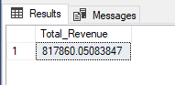

1. **Average Order Value:**

**SELECT ROUND(SUM(total_price)/COUNT(DISTINCT order_id),2) AS Average_Order_Value FROM pizza_sales;**

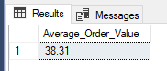

1. **Total Pizza Sold:**

**SELECT SUM(quantity) AS Total_Pizzas_Sold FROM pizza_sales;**

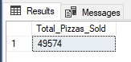

1. **Total Orders:**

**SELECT MAX(order_id) AS Number_of_Orders, Count(DISTINCT order_id) AS Number_of_Orders_2 FROM pizza_sales;**

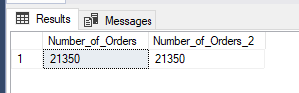

There are 2 different ways to calculate the total number of orders in this data. The first one is based on order_id’s because order_id’s start with one and continue incrementing one by one for each order, the second way is to use the count method with the distinct key.

1. **Average Pizzas per Order:**

**SELECT CAST(CAST(SUM(quantity) AS DECIMAL(10,2))/CAST(MAX(order_id) AS DECIMAL(10,2)) AS DECIMAL(10,2)) AS Avg_Pizzas_Per_Orders FROM pizza_sales;**

**Short way:**

**SELECT CAST(SUM(quantity)*1.0/ MAX(order_id) AS DECIMAL(10,2)) AS Avg_Pizzas_Per_Orders FROM pizza_sales;**

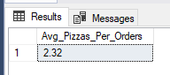

Note: If a number product with float number, the result will be float.

1. **Chart Red Queries**
2. **Hourly Trend for Total Pizza Sold**

**SELECT DATEPART(HOUR, order_time) Oreders_Hour, SUM(quantity) AS Total_Sold_Hourly FROM pizza_sales**

**GROUP BY DATEPART(HOUR, order_time)**

**ORDER BY Total_Sold_Hourly DESC;**

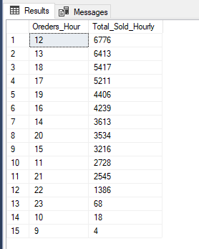

1. **Weekly Trend for Total Orders**

**SELECT DATEPART(ISO_WEEK, order_date) Week_Number, YEAR(order_date) Order_Year, COUNT(DISTINCT order_id) AS Total_Orders FROM pizza_sales**

**GROUP BY DATEPART(ISO_WEEK, order_date), YEAR(order_date)**

**ORDER BY Total_Orders DESC;**

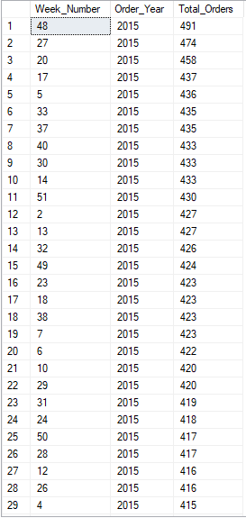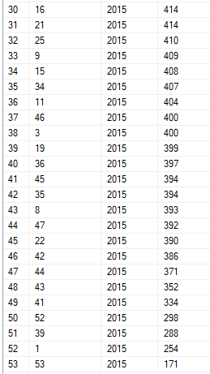

1. **Percentage of Sales by Pizza Category & Total Pizza Sold by Category**

**--Calculated by Quantity**

**SELECT pizza_category, SUM(quantity) Total_Sold_Pizza, SUM(quantity) * 100 / (SELECT SUM(quantity) FROM pizza_sales) AS perc_quantity FROM pizza_sales**

**GROUP BY pizza_category**

**ORDER BY Total_Sold_Pizza DESC;**

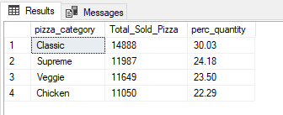

**--Calculated by Total_Price**

**SELECT pizza_category, CAST(SUM(total_price) AS DECIMAL(10,2)) Total_Price, CAST(SUM(total_price) * 100 / (SELECT SUM(total_price) FROM pizza_sales) AS DECIMAL(10,2)) AS perc_total_price FROM pizza_sales**

**GROUP BY pizza_category**

**ORDER BY Total_Price DESC;**

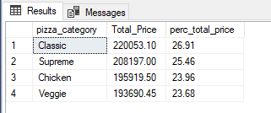

**--Indicate a Specific Month (Quantity)**

**\*Based on the total number of pizzas in the data**

**SELECT pizza_category, CAST(SUM(quantity) AS DECIMAL(10,2)) Total_Sold_Pizza, CAST(SUM(quantity) * 100.0 / (SELECT SUM(quantity) FROM pizza_sales) AS DECIMAL(10,2)) AS perc_quantity FROM pizza_sales**

**WHERE MONTH(order_date) = 12**

**GROUP BY pizza_category**

**ORDER BY Total_Sold_Pizza DESC;**

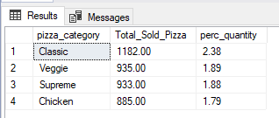

**--Indicate a Specific Month (Quantity)**

**\*Calculated based on the selected month**

**SELECT pizza_category, CAST(SUM(quantity) AS DECIMAL(10,2)) Total_Sold_Pizza, CAST(SUM(quantity) * 100.0 / (SELECT SUM(quantity) FROM pizza_sales WHERE MONTH(order_date) = 12) AS DECIMAL(10,2)) AS perc_quantity FROM pizza_sales**

**WHERE MONTH(order_date) = 12**

**GROUP BY pizza_category**

**ORDER BY Total_Sold_Pizza DESC;**

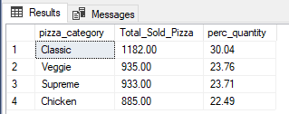

1. **Percentage of Sales by Pizza Size**

**SELECT pizza_size, SUM(quantity) AS Total_Pizzas, CAST(SUM(quantity) * 100.0 / (SELECT SUM(quantity) FROM pizza_sales) AS DECIMAL(10,2)) AS perc_quantity FROM pizza_sales**

**GROUP BY pizza_size**

**ORDER BY Total_Pizzas DESC;**

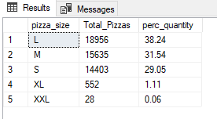

1. **Top 5 Best Sellers by Total Pizzas Sold**

**SELECT TOP 5 pizza_name, SUM(quantity) AS Total_Pizzas, CAST(SUM(quantity) * 100.0 / (SELECT SUM(quantity) FROM pizza_sales) AS DECIMAL(10,2)) AS perc_quantity FROM pizza_sales**

**GROUP BY pizza_name**

**ORDER BY Total_Pizzas DESC;**

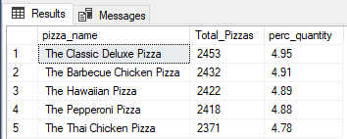

1. **Bottom 5 Worst Seller by Total Pizzas Sold**

**SELECT TOP 5 pizza_name, SUM(quantity) AS Total_Pizzas, CAST(SUM(quantity) * 100.0 / (SELECT SUM(quantity) FROM pizza_sales) AS DECIMAL(10,2)) AS perc_quantity FROM pizza_sales**

**GROUP BY pizza_name**

**ORDER BY Total_Pizzas;**

